1. Create a Sales table using sale_id, product_id, quantity_sold , sale_date , total_price with FOREIGN KEY (product_id) REFERENCES Products(product_id), and insert 10 data.

CREATE TABLE sales (

sale_id BIGINT AUTO_INCREMENT PRIMARY KEY,

product_id BIGINT NOT NULL,

FOREIGN KEY (product_id) REFERENCES products(product_id),

sale_date DATE NOT NULL,

quantity_sold INT NOT NULL,

total_price DECIMAL (20,2) NOT NULL

);

INSERT INTO sales (product_id, sale_date, quantity_sold, total_price) VALUES

(1, '2025-01-01', 10, 900.00),

(2, '2025-01-02', 5, 600.00),

(3, '2025-01-03', 2, 3000.00),

(4, '2025-05-04', 8, 640.00),

(5, '2025-05-05', 4, 600.00),

(6, '2025-05-06', 20, 500.00),

(7, '2025-05-07', 15, 900.00),

(8, '2025-05-08', 1, 25000.00),

(9, '2025-05-09', 3, 10500.00),

(10, '2025-05-10', 2, 4000.00);

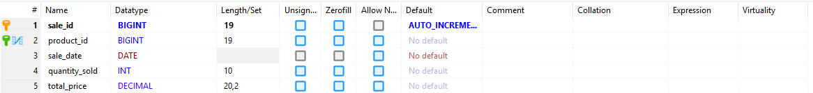

1. Create a Product table using product_id, product_name , category, unit_price and insert 10 data.

CREATE TABLE products (

product_id BIGINT AUTO_INCREMENT PRIMARY KEY,

product_name VARCHAR(255) NOT NULL,

category VARCHAR(255) NOT NULL,

unit_price DECIMAL (20,2) NOT NULL

);

INSERT INTO products (product_name, category, unit_price) VALUES

('Milk', 'Grocery', 90.00),

('Sugar', 'Grocery', 120.00),

('Rice (Milled)', 'Grocery', 1500.00),

('Toothpaste', 'Daily Use', 80.00),

('Shampoo', 'Daily Use', 150.00),

('Pen', 'Stationery', 25.00),

('Notebook', 'Stationery', 60.00),

('Mobile Phone', 'Electronics', 25000.00),

('Headphones', 'Electronics', 3500.00),

('Shoes', 'Apparel', 2000.00);  
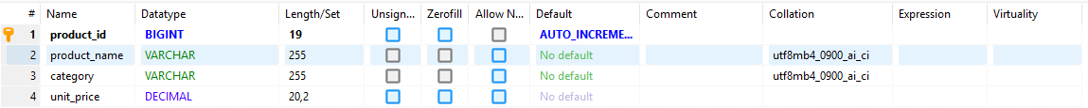

1. Retrieve all columns from the Sales table.   
     
   SELECT * from sales;  
   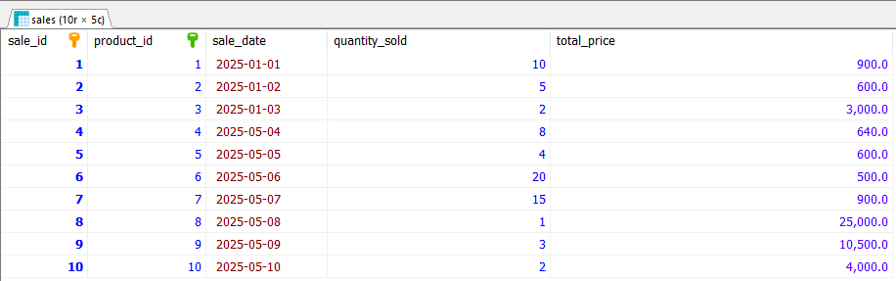
2. Retrieve the product_name and unit_price from the Products table.  
     
   SELECT product_name, unit_price FROM products;  
   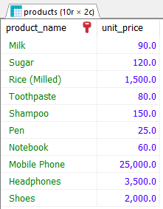
3. Retrieve the sale_id and sale_date from the Sales table.   
     
   SELECT sale_id, sale_date FROM sales;  
   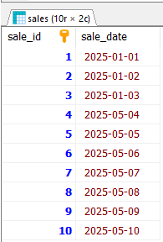
4. Filter the Sales table to show only sales with a total_price greater than $1570.   
     
   SELECT * from sales WHERE total_price > 1570;  
   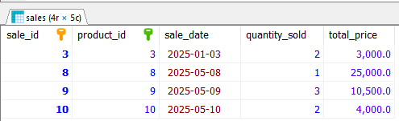
5. Retrieve the sale_id and total_price from the Sales table for sales made on January 3, 2025.  
     
   SELECT sale_id, total_price FROM sales WHERE sale_date='2025-01-03';  
   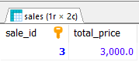
6. Calculate the total revenue generated from all sales in the Sales table.  
     
   SELECT SUM(total_price) AS total_revenue FROM sales;  
   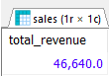
7. Calculate the average unit_price of products in the Products table.   
     
   SELECT SUM(unit_price)/COUNT(*) AS average_unit_price FROM products;  
   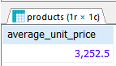
8. Count Sales Per Day from the Sales table.  
     
   SELECT sale_date, COUNT(*) AS sale_per_day FROM sales GROUP BY sale_date;  
   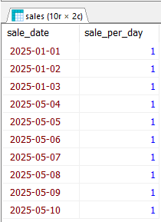
9. Retrieve the total_price of all sales, rounding the values to two decimal places.  
     
   SELECT ROUND(SUM(total_price), 2) AS total_sales FROM sales;  
   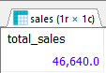
10. Retrieve the sale_id and sale_date from the Sales table, formatting the sale_date as 'YYYY-MM DD'.   
      
    SELECT sale_id, DATE_FORMAT(sale_date, '%Y-%m-%d') AS formatted_sale_date FROM sales;  
    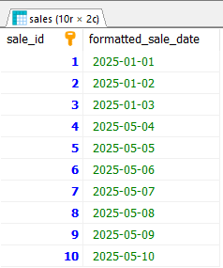

1. Rank products based on total sales revenue.

SELECT

p.product_id,

p.product_name,

SUM(s.total_price) AS total_revenue,

RANK() OVER (ORDER BY SUM(s.total_price) DESC) AS revenue_rank

FROM

products p

JOIN

sales s ON p.product_id = s.product_id

GROUP BY

p.product_id

ORDER BY

total_revenue DESC;  
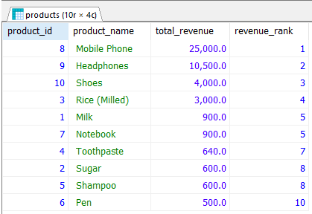

1. Categorize sales as "High", "Medium", or "Low" based on total price (e.g., > $2000 is High, $1100-$1999 is Medium, < $1099 is Low).

SELECT

sale_id,

sale_date,

total_price,

CASE

WHEN total_price > 2000 THEN 'High'

WHEN total_price BETWEEN 1100 AND 1999 THEN 'Medium'

ELSE 'Low'

END AS sales_category

FROM

sales

ORDER BY

total_price DESC;

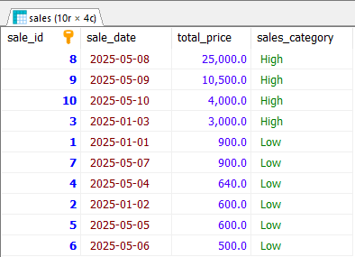

1. Retrieve the product details (name, category, unit price) for products that have a quantity sold greater than the average quantity sold across all products.

SELECT

p.product_name,

p.category,

p.unit_price

FROM

products p

JOIN

sales s ON p.product_id = s.product_id

GROUP BY

p.product_id

HAVING

SUM(s.quantity_sold) > (

SELECT AVG(total_quantity)

FROM (

SELECT SUM(quantity_sold) AS total_quantity

FROM sales

GROUP BY product_id

) AS avg_sales

)

ORDER BY

p.product_name;

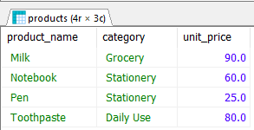

1. Add a foreign key constraint to the Sales table that references the product_id column in the Products table.  
     
   Already done in question 1.
2. Implement a transaction that deducts the quantity sold from the Products table when a sale is made in the Sales table, ensuring that both operations are either committed or rolled back together.

ALTER TABLE products

ADD COLUMN stock_quantity INT NOT NULL DEFAULT 0;

DROP PROCEDURE IF EXISTS Process_Sale;

DELIMITER $$

CREATE PROCEDURE Process_Sale (

IN p_product_id BIGINT,

IN p_sale_date DATE,

IN p_quantity_sold INT

)

BEGIN

DECLARE p_total_price DECIMAL(20,2);

DECLARE v_unit_price DECIMAL(20,2);

DECLARE v_stock_quantity INT;

DECLARE v_error_message VARCHAR(255);

START TRANSACTION;

SELECT unit_price, stock_quantity INTO v_unit_price, v_stock_quantity

FROM products

WHERE product_id = p_product_id

FOR UPDATE;

IF v_stock_quantity >= p_quantity_sold THEN

SET p_total_price = v_unit_price * p_quantity_sold;

INSERT INTO sales (product_id, sale_date, quantity_sold, total_price)

VALUES (p_product_id, p_sale_date, p_quantity_sold, p_total_price);

UPDATE products

SET stock_quantity = stock_quantity - p_quantity_sold

WHERE product_id = p_product_id;

COMMIT;

ELSE

SET v_error_message = 'Not enough stock available.';

ROLLBACK;

SIGNAL SQLSTATE '45000' SET MESSAGE_TEXT = v_error_message;

END IF;

END$$

DELIMITER ;

CALL Process_Sale(3, '2025-05-20', 5);



1. Write a query to find all sales where the total price is greater than the average total price of all sales.

SELECT *

FROM sales

WHERE total_price > (

SELECT AVG(total_price)

FROM sales);  
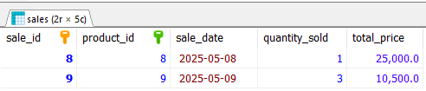

1. Develop a stored procedure named Update_Unit_Price that updates the unit price of a product in the Products table based on the provided product_id.

DROP PROCEDURE IF EXISTS Update_Unit_Price;

DELIMITER $$

CREATE PROCEDURE Update_Unit_Price (

IN p_product_id BIGINT,

IN p_new_price DECIMAL(20,2)

)

BEGIN

UPDATE products

SET unit_price = p_new_price

WHERE product_id = p_product_id;

END$$

DELIMITER ;  
  
SELECT product_id,unit_price FROM products WHERE product_id=1;  
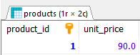  
CALL Update_Unit_Price(1,60.50);  
SELECT product_id,unit_price FROM products WHERE product_id=1;  
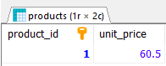

1. Implement a transaction that inserts a new product into the Products table and then adds a corresponding sale record into the Sales table, ensuring that both operations are either fully completed or fully rolled back.

DROP PROCEDURE IF EXISTS Add_Product_And_Sale;

DELIMITER $$

CREATE PROCEDURE Add_Product_And_Sale(

IN p_product_name VARCHAR(255),

IN p_category VARCHAR(255),

IN p_unit_price DECIMAL(20,2),

IN p_stock_quantity INT,

IN qty_sold INT

)

BEGIN

DECLARE new_pid INT;

START TRANSACTION;

INSERT INTO Products (product_name, category, unit_price, stock_quantity)

VALUES (p_product_name, p_category, p_unit_price, p_stock_quantity);

SET new_pid = LAST_INSERT_ID();

INSERT INTO Sales (product_id, quantity_sold, sale_date, total_price)

VALUES (new_pid, qty_sold, CURDATE(), qty_sold * p_unit_price);

UPDATE Products

SET stock_quantity = stock_quantity - qty_sold

WHERE product_id = new_pid

AND stock_quantity >= qty_sold;

IF ROW_COUNT() = 0 THEN

ROLLBACK;

SIGNAL SQLSTATE '45000'

SET MESSAGE_TEXT = 'Insufficient stock for new product sale';

ELSE

COMMIT;

END IF;

END$$

DELIMITER ;

CALL Add_Product_And_Sale('Potato', 'Grocery','20',10.5,5);  
